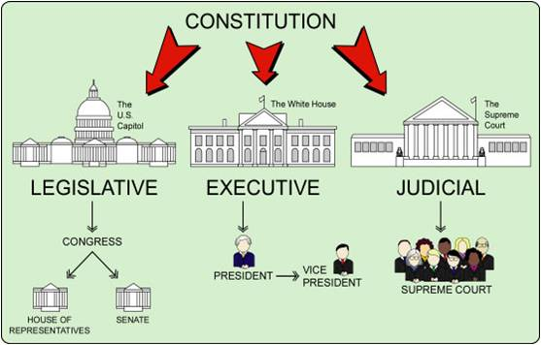
SEPARATION OF POWERS – THE 3 BRANCHES OF GOVERNMENT

Branch | What is the main responsibility? | Who? | Powers (As mentioned in the Constitution) | Term Limits
Legislative | Make the laws | Upper House or Senate (2 senators per state) and the Lower House or House of Representatives (# reps per state is based on state population) This is the so-called “Great Compromise) | Examples:  Collect taxes, regulate foreign and domestic commerce, coin money, declare war, support an army and navy, and establish lower federal court | 6 years (Senators)  2 years (Representatives)  *While congressional members have term limits, they can in most cases run for reelection continually, meaning that, if they keep winning, they could effectively hold onto the seat for life.
Executive | Execute/carry out the laws | President  Vice President  Cabinet (example of the unwritten constitution) | - Make treaties  - Veto laws  - Presidential pardons | 2 terms (each term is 4 years – so 8 years total)
Judicial | Interpret the law | 9 Justices – one of which  serves as the Chief Justice) | Judicial Review – the power to determine if a law is constitutional or unconstitutional. | Life

